What I did for my MSc Project

Jon Doe

Department of Computer Science

Aberystwyth University

Wales

January

2018

This thesis is submitted in partial fulfilment of the requirements for the degree of Master of Science

Degree: MSc Data Science

Module: CSM9060

Supervisor: Dr Who

ABSTRACT

The abstract stands alone as a very short version of the dissertation.

The abstract should state the scope and principal objectives of the project, describe the methods, summarize the results and state the principal conclusions.

ACKNOWLEDGEMENTS

To whoever has the patience to read this :-)

This section is customary, but not obligatory. It makes a brief statement of thanks to those who have helped.

Table of Contents

Chapter 1. Introduction 1

Chapter 2. Literature review 2

Chapter 3. Reporting on the project – the core chapters 3

Chapter 4. Critical Evaluation 4

Chapter 5. Conclusion 5

References 6

List of Figures

Figure 1 Structure of a dynamic website (Edel Sherratt) 3

1. Introduction

Background to the project, motivation, leading to project aims and objectives.

1. Literature review

The literature review is all about the related knowledge that you are building on. Similar products and related research are usual.

Remember to use your own words and to show relevance to your project aim.

The literature review will refer extensively to the bibliography. Harvard (author-date) and IEEE reference styles are usual in Computer Science, but the only real rule is that you should use a consistent style.

Here is an example reference to inky matters [1].

Refereed articles are generally considered to have the greatest authority, but for a Computer Science project you are also likely to cite other sources, such as technical documents, user manuals, standards documents, web pages and books.

When you cite a web source, make sure to include the date of access.

1. Reporting on the project – the core chapters

Reporting on the project will normally require more than one chapter.

A development project is likely to have chapters addressing requirements, design, implementation, testing and packaging if a plan-driven method is used. If an agile approach is taking, you might have a chapter for each sprint or iteration.

Other kinds of project will have chapters that are appropriate to the project in question.

You are likely to include diagrams or images in your core chapters (see Figure 1.)

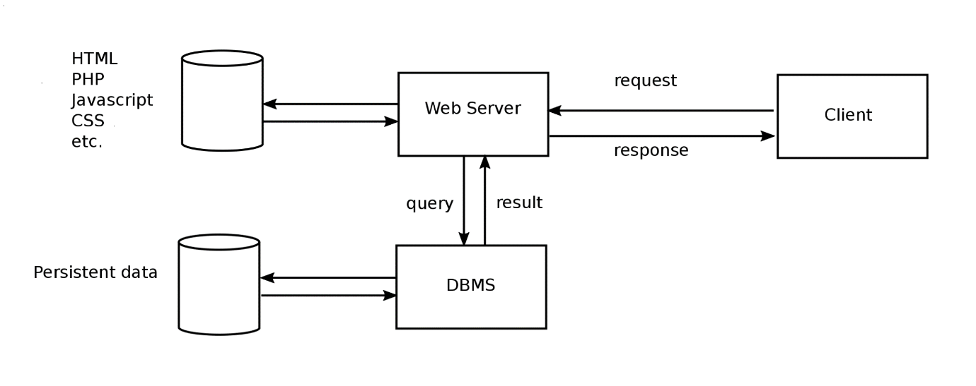

Figure 1 Structure of a dynamic website (Edel Sherratt)

You can refer to your figure from more than one place (Figure 1.)

1. Critical Evaluation

In this chapter (it won’t be chapter 4, but probably chapter 6 or 7 once all the core chapters have been added.)

The critical evaluation consists of a discussion, leading to conclusion. It is an essential part of a master’s degree.

It shows that you can not only carry out a substantial piece of work, but that you can reflect on it, and think critically about how you might have done it better.

Examiners view the critical evaluation as very important.

1. Conclusion

A brief summary of all that has gone before, including the key results of the project.

May also include some directions for future work.

# References

|  |  |
| --- | --- |
| [1] | I. Jones, “New kinds of red ink,” *Inky Journal of Pigments,* vol. 336, no. 5, pp. 55-58, March 2010. |